

Coding Job Spec
Studio Ini is looking for a creative coder to develop a quick and dirty communication protocol working between: kinect, arduino and a plc type controller. The work would be part of a new project exploring the role of digital technology alongside craft processes in glass blowing. The project will be exhibited at the V&A Digital Design Weekend 2017 and the applicant will be credited for their contribution.

Deadline: 28/08 (Working prototype) → 3/09 Stable prototype
Salary: Dependant on applicants experience

Overview:
The project will require the software to take in information from a Kinect V2 and an Adafruit Bno055 IMU mounted on an arduino based platform communicating through xbee sensors. The information would then be processed according to our rule base and used to control pressure flow through an arduino controlled plc device.
Kinect V2
Bno055 IMU Arduino
Cable connect
Xbee connect
Communication protocol on computer, processing information
Arduino PLC controlling airflow
Inputs
Outputs

Detail:
Below details the main routine, which will combine all the sensor readings and with a simple rule based algorithm will actuate and control the airflow system.

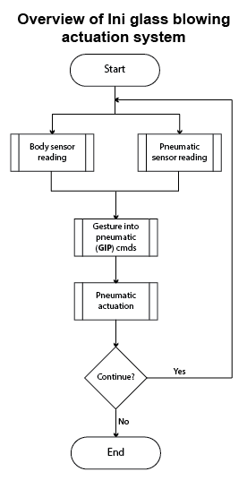

Sensing routines:
I anticipate that the Body sensor reading will be the hardest routine to program, as we will need to define a series of states or conditions to be recognised as discrete outputs. Also, if the leap sensor and the kinect fail, we will need to use an IMU to detect different states. The pneumatic sensor reading will be trivial.
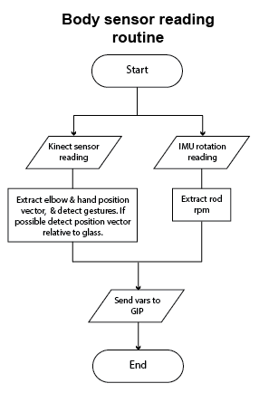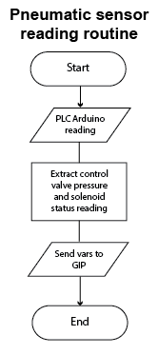

Gesture into Pneumatic routine:
This routine will rely mainly on the rules which will be drawn out on the 23rd of August. They will form the basis of the algorithm which converts the sensor readings into conditions which the PLC will be able to use to control pressure. The switch statements will cover all the outputs for this project. There will be no continuous or proportional functions in order to simplify the system.
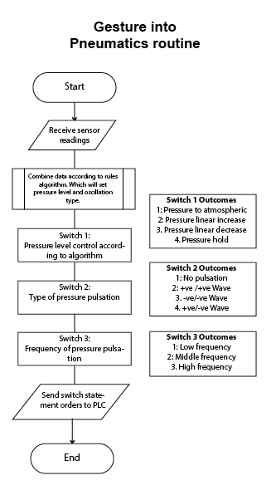

Pneumatic actuation routine:
This will be the simplest, the arduino controlled PLC will act on serial based commands to control the pneumatic system.
